Final Project Report

Women's E-Commerce Clothing Reviews Analysis Using Machine Learning



Project Supervisor
Hina Ishaq

Submitted By

Group ID: S2301DB808

Rehana Zouq MC160400852

Software Projects & Research Section,
Department of Computer Sciences,
Virtual University of Pakistan


CERTIFICATE

This is to certify that Rehana Zouq (MC160400852) have worked on and completed their Software Project at Software & Research Projects Section, Department of Computer Sciences, Virtual University of Pakistan in partial fulfillment of the requirement for the degree of BS in Computer Sciences under my guidance and supervision.

In our opinion, it is satisfactory and up to the mark and therefore fulfills the requirements of BS in Computer Sciences.

Supervisor / Internal Examiner

Hina Ishaq
Supervisor,
Software Projects & Research Section,
Department of Computer Sciences
Virtual University of Pakistan

___________________
(Signature)

External Examiner/Subject Specialist
<<External Supervisor Name>>

___________________
(Signature)

Accepted By:

_____________
(For office use)

EXORDIUM

In the name of Allah, the Compassionate, the Merciful.

Praise be to Allah, Lord of Creation,
The Compassionate, the Merciful,
King of Judgment-day!

You alone we worship, and to You alone we pray for help,
Guide us to the straight path

The path of those who You have favored,

Not of those who have incurred Your wrath,
Nor of those who have gone astray.

DEDICATION

In the name of Allah, the Compassionate, the Merciful.

This project is humbly dedicated to Allah Almighty, the Most Gracious and Most Merciful, the Lord of all creation. In recognition of His boundless wisdom and guidance, we embark on this journey of knowledge and discovery. May this endeavor be a reflection of our gratitude for the blessings bestowed upon us, and may it contribute positively to the world of technology and understanding
ACKNOWLEDGEMENT

I express my sincere gratitude to my project supervisor, Hina Ishaq, for her invaluable guidance, support, and encouragement throughout the duration of this project. Her expertise and insights have been instrumental in shaping the success of this endeavor.

I would also like to extend my thanks to the Virtual University of Pakistan, Software Projects & Research Section, Department of Computer Sciences, for providing a conducive environment for learning and research.

Lastly, a special thanks to all the researchers, educators, and professionals whose work has paved the way for advancements in machine learning, making projects like this possible.

PREFACE

In the realm of e-commerce, customer sentiments play a pivotal role in shaping business outcomes. This project delves into the analysis of women's clothing reviews, employing machine learning techniques to unveil insights that can guide decision-making in the textile industry. The journey involves a meticulous process of data gathering, preprocessing, model implementation, and evaluation, with the ultimate aim of understanding and harnessing the power of customer feedback.

This document serves as a comprehensive report detailing the project's inception, planning, execution, and findings. From the initial conceptualization to the intricate aspects of model training and analysis, every phase is articulated to provide a transparent and insightful view of the project.

As we embark on this exploration of sentiment analysis in the context of e-commerce clothing reviews, I hope this document serves as a valuable resource for those interested in the intersection of machine learning and customer feedback analysis.
TABLE OF CONTENTS

CHAPTER NO. 1
gathering & Analyzing info 1

1.1 Introduction

1.2 purpose

1.3 scope

1.4 definitions, acronyms and abbreviations

1.5 Project requirements

1.5.1 Functional Requirements

1.5.2 Non-Functional Requirements

1.6 use cases and usage scenarios

1.6.1 Use Case Diagrams

1.6.2 Usage Scenarios

1.7 Work Plan (Gantt Chart)

CHAPTER NO. 2
designing the project 11

2.1 Introduction

2.2 purpose

2.3 scope

2.4 definitions, acronyms and abbreviations

2.5 Architectural Representation (Architecture Diagram)

2.6 Dynamic Model: Sequence Diagrams

2.7 Object Model/Logical Model: Class Diagram

Chapter no.3
DEvelopment 17
3.1 Development plan (Architecture Diagram)

CHAPTER NO. 4
Model Implementation 19

4.1 Model Selection and Setup

4.2 Training Process

CHAPTER NO. 5
Evaluation and Results 22

5.1 Performance Metrics

5.2 Model Comparison

CHAPTER NO. 6
Discussion and Analysis 25

6.1 Findings

6.2 Unexpected Results

CHAPTER NO. 7
CONCLUSION 28

7.1 Summary

7.2 Limitations and Future Work

CHAPTER 1
Gathering & Analyzing Info

  - Introduction

Ecommerce is a method of buying and selling goods and services online. Although the fashion industry developed first in Europe and America, today it is an international and highly globalized industry. The Internet has made the world a smaller place. It has facilitated long distance communication by making the process cheaper, faster, and easier. Today, the internet helps business industry to cater to a global audience without any major investment. Customer reviews act as powerful social proof. While your online customers may lack the ability to see or touch the product, they can read through reviews to still make well-informed purchase decisions. Reviews create credibility for the products, and increased credibility means increased sales.
In this project, students will use sentiment analysis to determine whether the product is recommended or not and find accuracy by applying appropriate machine learning techniques (such as Logistic Regression, Decision Tree, and Random Forest etc.) to given datasets. Students will also compare which technique is best and why. The outcomes of this analysis will benefit both the researchers and textile industries.

  - Purpose

The purpose of the Women's E-Commerce Clothing Reviews Analysis project is to utilize sentiment analysis to determine the recommendation status of products based on customer reviews. The project aims to apply machine learning techniques, including Logistic Regression, Decision Tree, and Random Forest, to analyze datasets and compare the effectiveness of these techniques. The outcomes of this analysis are expected to provide valuable insights for both researchers and the textile industries.

  - Scope

The scope of the Women's E-Commerce Clothing Reviews Analysis project includes developing a prototype system for analyzing clothing reviews from an e-commerce platform using machine learning techniques. The project involves tasks such as data collection, preprocessing, dataset splitting, model selection and training, evaluation of trained models, analysis of results and model retraining.

  - Definitions, Accronyms and Abbrevietions

- E-commerce: Electronic Commerce
- Machine Learning (ML): A subset of artificial intelligence (AI) that focuses on the development of algorithms allowing systems to learn and make predictions or decisions without explicit programming.
- Kaggle: An online platform for data science competitions, datasets, and discussions.
- Tokenization: The process of breaking down text into words or phrases (tokens) for analysis.
- Stop Word Removal: The elimination of common words (e.g., "and," "the") from text data to focus on meaningful words.
- Lemmatization: The process of reducing words to their base or root form.
- Confusion Matrix: A table used to evaluate the performance of a classification model, displaying true positive, true negative, false positive, and false negative values.
- Accuracy: The measure of a model's correctness, calculated as the ratio of correctly predicted instances to the total instances.

- Precision: The ratio of correctly predicted positive observations to the total predicted positives.
- Recall: The ratio of correctly predicted positive observations to the all observations in actual class.
- Anaconda: A distribution of Python and R programming languages used for data science and machine learning.
- IDEs: Integrated Development Environments, software platforms providing comprehensive tools for programming.

  - Requirements

    - Functional Requirements

The functional requirements for the project include:
- Collecting data from the Kaggle platform for clothing reviews, with a dataset of at least 2000 records.
2. Applying data processing techniques like tokenization, stop word removal, and lemmatization to preprocess the collected dataset.
3. Splitting the preprocessed dataset into training and testing sets.
4. Selecting and training machine learning models (e.g., Logistic Regression, Decision Tree, Random Forest) using the training dataset.
5. Evaluating the trained models using performance metrics like Confusion Matrix, Accuracy, Precision, and Recall.
6. Analyzing and discussing the results of different algorithms and comparing their performance.
7. Retraining the model if the accuracy is below 60% by adjusting training parameters.
8. Documenting the project, including the methodology, implementation details, results, and findings.

    - Non-Functional Requirements

The non-functional requirements for the project include:

- Ensuring efficient performance during data processing, model training, and evaluation.
- Achieving a minimum accuracy of 60% for the trained models.
- Designing a user-friendly interface for easy interaction with the system.
- Ensuring reliability and robustness under normal operating conditions.
- Implementing appropriate security measures to protect sensitive data.
- Ensuring compatibility with required software tools and platforms, such as Anaconda, Python, and relevant IDEs.

  - Use Cases and Usage Scenerios

    - Use Case Diagrams

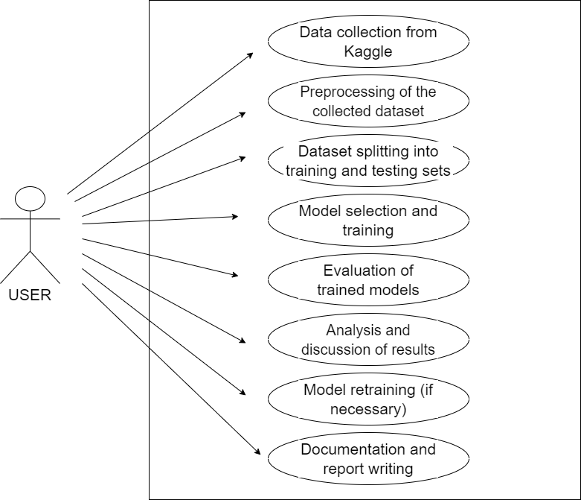

    - Usage Scenerios

The usage scenarios for the Women's E-Commerce Clothing Reviews Analysis project include:

- Data Collection: Collecting the dataset from Kaggle platform for clothing reviews.
2. Data Processing: Applying data processing techniques to preprocess the collected dataset.
3. Dataset Splitting: Splitting the preprocessed dataset into training and testing sets.
4. Model Training: Selecting and training machine learning models using the training dataset.
5. Model Evaluation: Evaluating the trained models using performance metrics.
6. Result Analysis and Discussion: Analyzing and discussing the results of different algorithms and comparing their performance.
7. Model Retraining: Retraining the model by adjusting training parameters.
8. Documentation and Report Writing: Documenting the project, including the methodology, implementation details, results, and findings.

  - Work Plan (Gantt Chart)

ID | Work Breakdown Structure | Start | End | Person | Progress | Dependency
1 | SRS | 14/07/2023 | 14/07/2023 | Rehana | 100%
2 | Design Document | 15/07/2023 | 13/09/2023 | Rehana | 100% | SRS
3 | Data collection from Kaggle | 14/09/2023 | 16/09/2023 | Rehana | 100% | Design Document
4 | Preprocessing of the collected dataset | 17/09/2023 | 19/09/2023 | Rehana | 100% | Data collection from Kaggle
5 | Dataset splitting into training and testing sets | 20/09/2023 | 21/09/2023 | Rehana | 100% | Preprocessing of the collected dataset
6 | Model selection and training | 22/09/2023 | 04/10/2023 | Rehana | 100% | Dataset splitting into training and testing sets
7 | Evaluation of trained models | 05/10/2023 | 15/10/2023 | Rehana | 100% | Model selection and training
8 | Analysis and discussion of results | 16/10/2023 | 29/10/2023 | Rehana | 100% | Evaluation of trained models
9 | Model retraining (if necessary) | 30/10/2023 | 12/11/2023 | Rehana | 100% | Analysis and discussion of results
10 | Documentation and report writing | 13/11/2023 | 04/12/2023 | Rehana | 100% | Model retraining (if necessary)
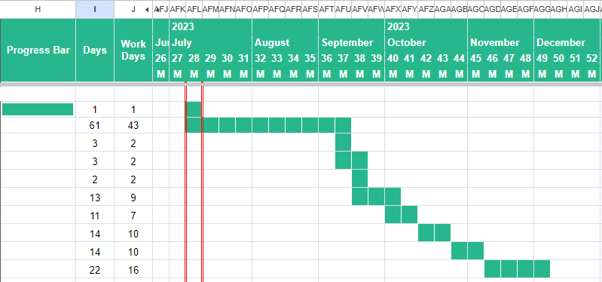

CHAPTER 2
Designing the Project

2.1 Introduction
The design of the document encompasses the structural and organizational aspects that guide the presentation of information in a cohesive manner. This section provides an overview of the design principles applied to ensure clarity, accessibility, and comprehensiveness in conveying the project details.
2.2 Purpose
The purpose of the document design is to present the Women's E-Commerce Clothing Reviews Analysis project information in a format that facilitates understanding and reference. It aims to systematically arrange content, making it accessible for both technical and non-technical readers. The design ensures that the document serves its intended purpose of communicating project goals, methodologies, and outcomes effectively.

2.3 Scope
The scope of the document design encompasses structuring information in a way that aligns with the project's objectives. It includes determining the hierarchy of sections, the placement of visual elements, and the overall layout to provide a comprehensive view of the project's various aspects. The scope also involves considering the audience's perspective for better engagement.

2.4 Definitions, Acronyms, and Abbreviations

Document Structure: The arrangement of sections, sub-sections, and their interconnections for logical flow.Visual Elements: Incorporation of figures, tables, and diagrams to enhance understanding.Consistency: Maintaining uniformity in formatting, font styles, and visual elements throughout the document.Accessibility: Ensuring that the document is accessible to readers with varying levels of technical expertise.Clarity: Using clear and concise language to convey complex technical concepts.Cross-referencing: Providing links and references for easy navigation within the document.Comprehensiveness: Including all relevant details while avoiding unnecessary information.This section focuses on the deliberate design choices made to optimize the document for effective communication and comprehension, catering to the diverse audience that may engage with the project report.

2.5 Architectural Representation (Architecture Diagram)

- Overview
The Architecture Design Diagram defines the high-level architecture of the system, including the components, their interactions, and the system's overall structure.
- System Architecture

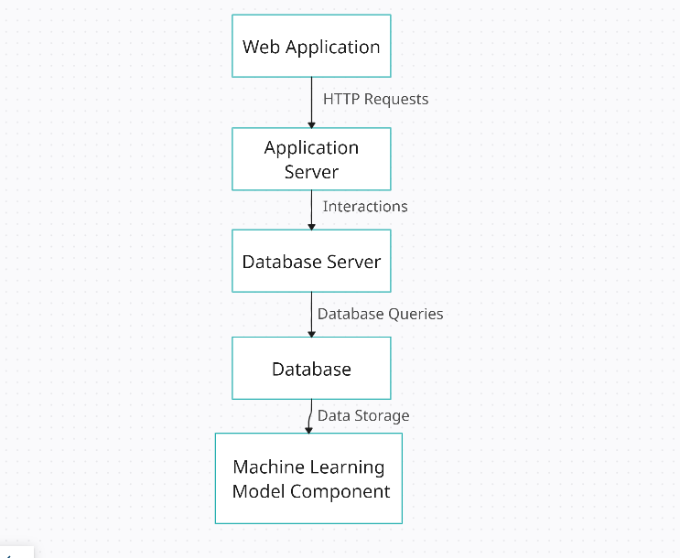
2.6 Dynamic Model: Sequence Diagrams

- Overview
Sequence Diagrams depict the interactions between system components and actors during specific use cases. They provide a visual representation of the flow of activities in the system.
- Sequence Diagrams for Each Use Case

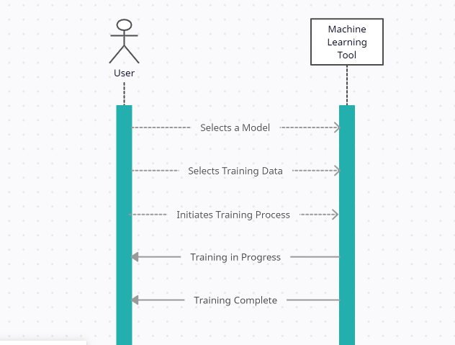

2.7 Object Model/Logical Model: Class Diagram
- Overview
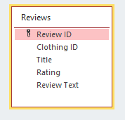
The Entity Relationship Diagram (ERD) illustrates the relationships between different entities in the system. It outlines how data will be organized and related within the system.
- Class Diagram

CHAPTER 3
Development

3.1 Architectural Overview
Our sentiment analysis project adopts a modular architecture. Key components include data preprocessing, model implementation , and evaluation modules. Data flows seamlessly through these components, ensuring an efficient sentiment analysis pipeline.
But here I provide the architecture diagram of this project.

CHAPTER 4
Model Implementation

4.1 Model Selection and Setup
We selected Logistic Regression, Decision Tree, and Random Forest for sentiment analysis. Implementation involved coding the models, setting up parameters, and ensuring compatibility with our dataset.

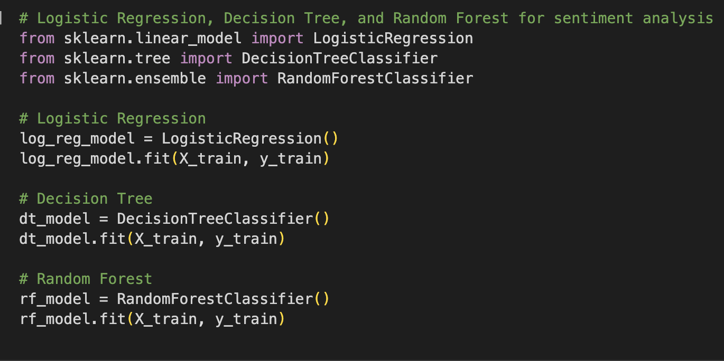

4.2 Training Process
The training process involved feeding our preprocessed dataset into the models. Hyperparameter tuning was conducted to enhance model performance. Challenges, such as ensuring convergence in Logistic Regression, were addressed.
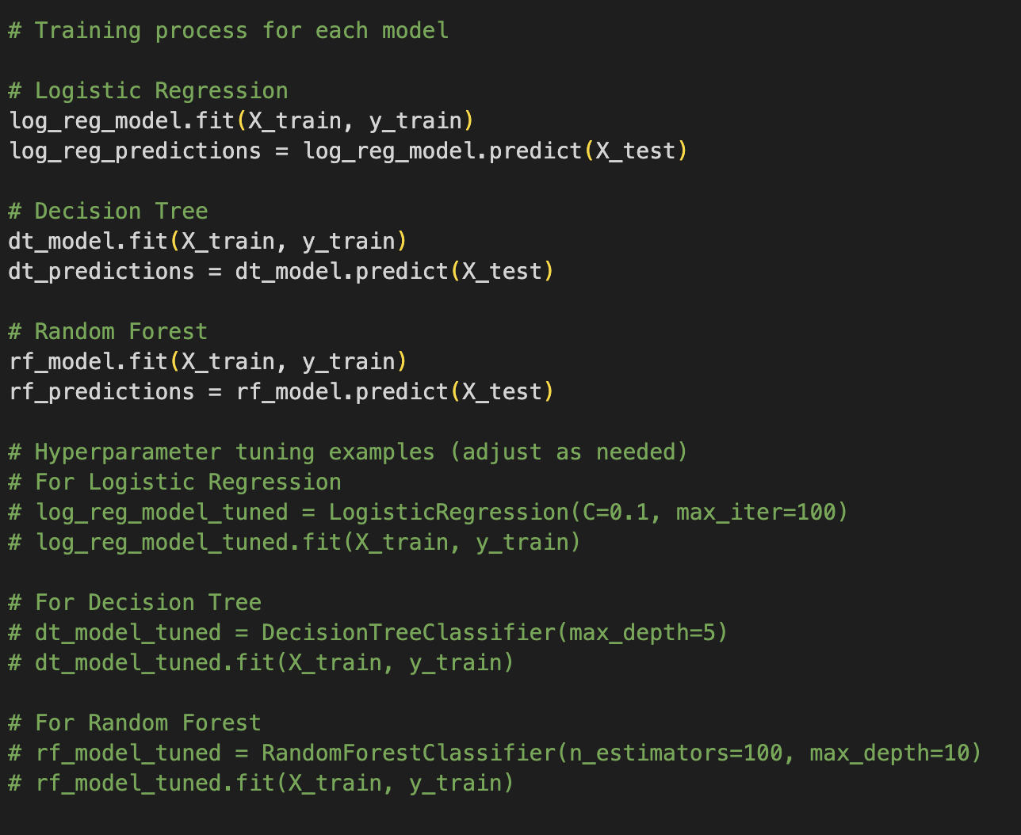

CHAPTER 5
Evaluation and Results

5.1 Performance Metrics

Our models were evaluated using accuracy, precision, recall, and confusion matrix metrics.

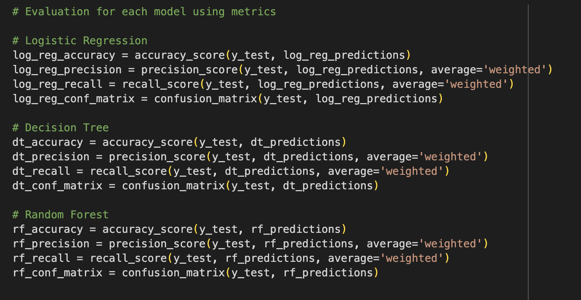

5.2 Model Comparison

Results revealed varying strengths and weaknesses among models. Visualizations, including ROC and precision-recall curves, provided a comprehensive comparison.

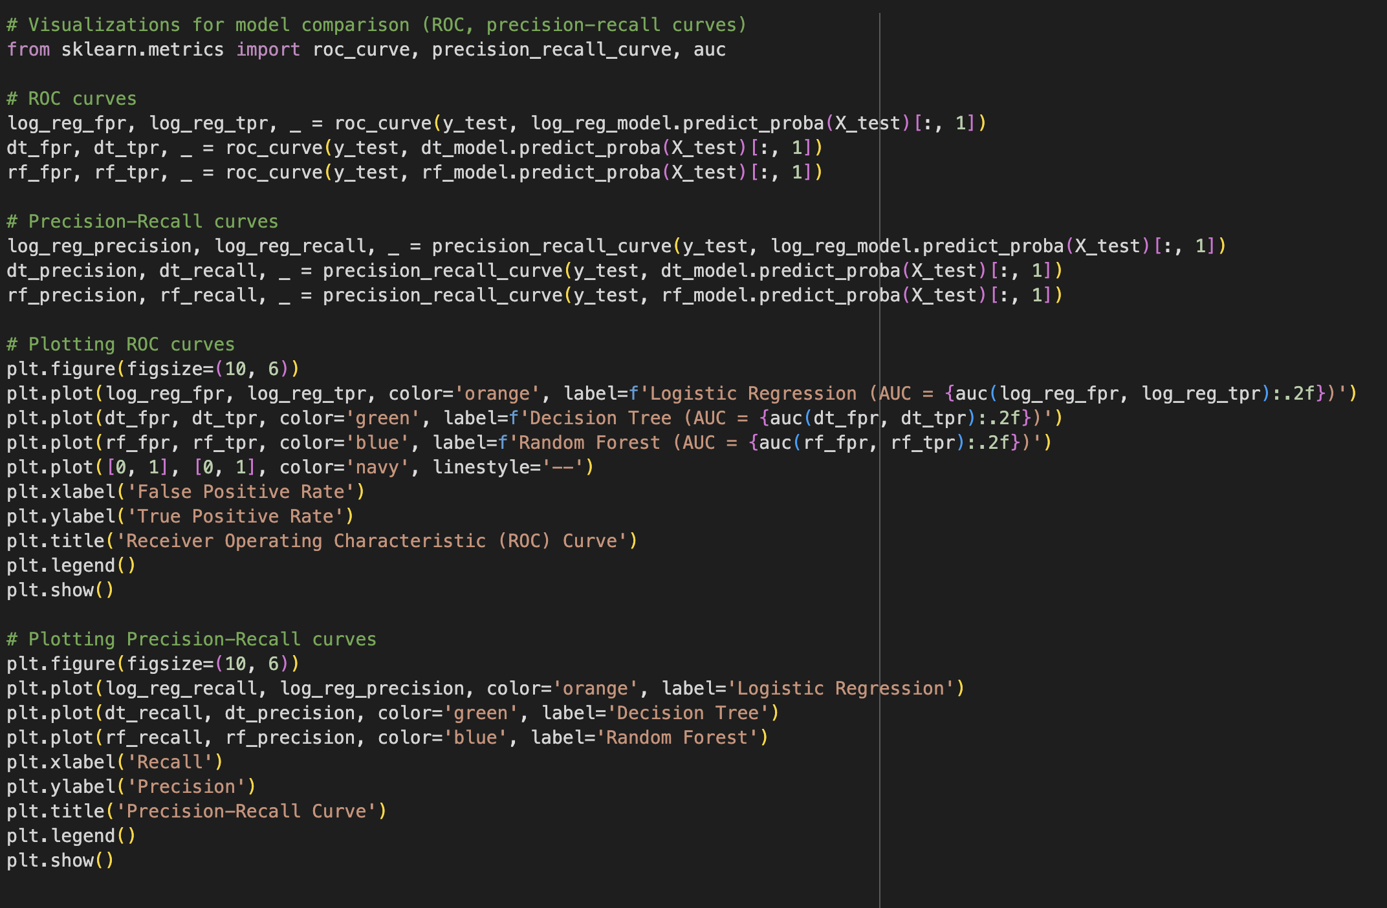

CHAPTER 6
Discussion and Analysis

6.1 Findings

Analysis of sentiment patterns unveiled valuable insights. Results were directly related to our initial project goals, contributing to a better understanding of customer sentiments.

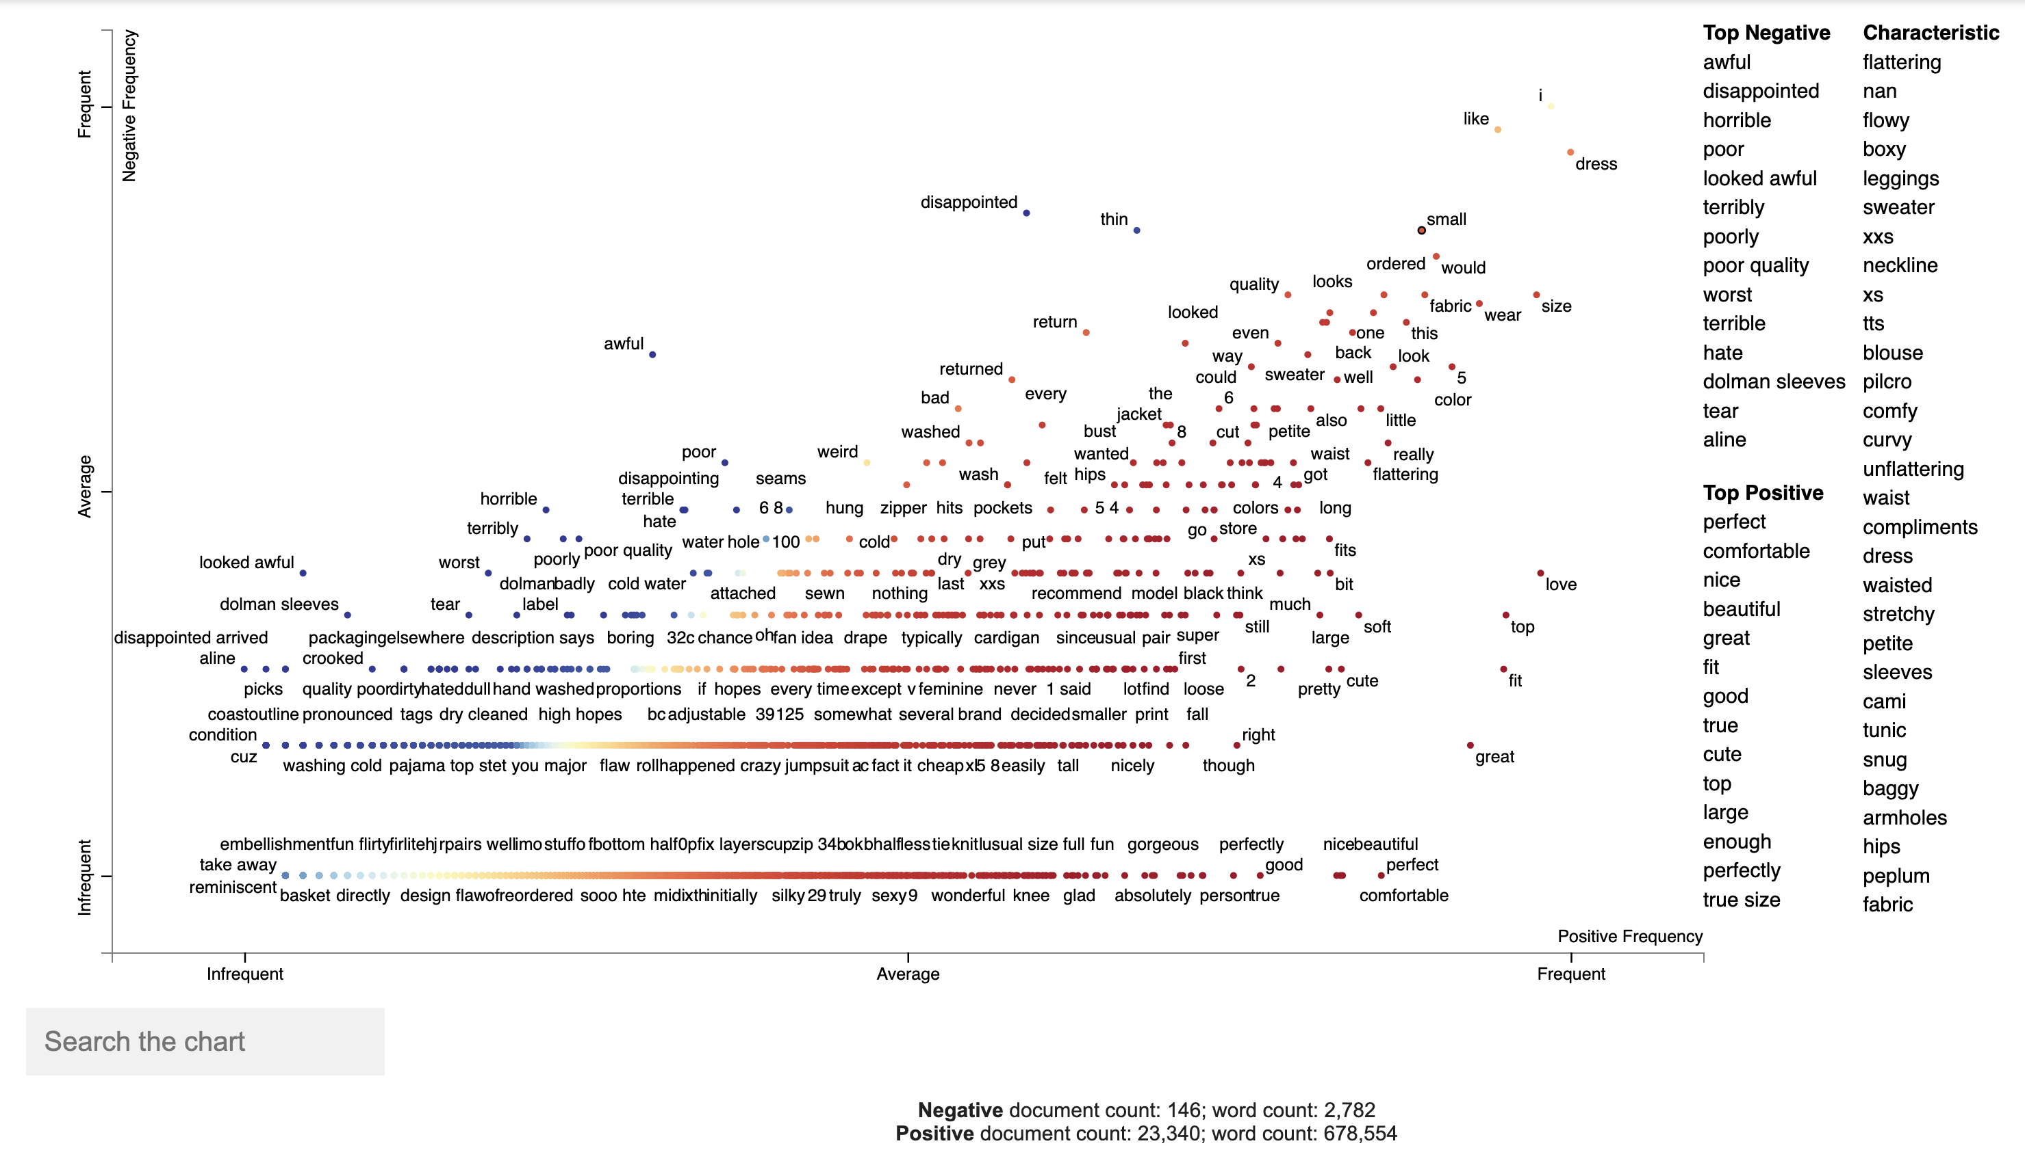

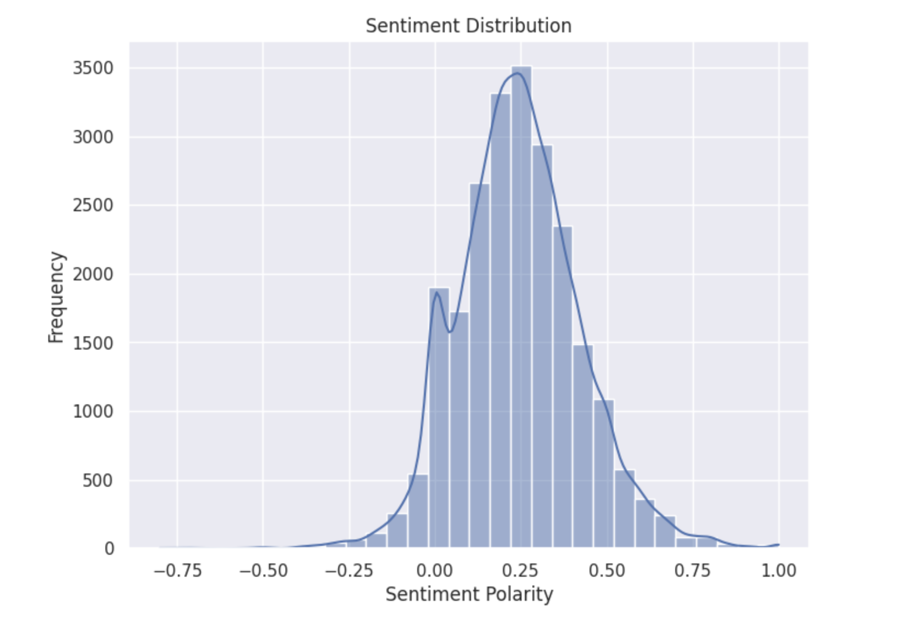

6.2 Unexpected Results

Surprises in the analysis prompted further investigation. Possible reasons for unexpected outcomes were explored, and potential implications were considered.

CHAPTER 7
Conclusion

7.1 Summary

In summary, our sentiment analysis project successfully achieved its goals. Key findings and insights were extracted, providing a deeper understanding of customer sentiments in e-commerce clothing reviews.

7.2 Limitations and Future Work

While successful, the project had limitations. Future work could involve exploring additional models or incorporating more features for a more robust sentiment analysis system.

REFERENCES

Brownlee, J. (2019). Machine Learning Algorithms: A Beginner’s Guide. Towards Data Science. LinkBrownlee, J. (2018). Top 10 Algorithms for Machine Learning Beginners. Towards Data Science. LinkBrownlee, J. (2020). 10 Machine Learning Methods That Every Data Scientist Should Know. Towards Data Science. LinkTutorialspoint. (n.d.). Logistic Regression in Python. LinkGeeksforGeeks. (n.d.). ML | Logistic Regression using Python. LinkSentdex. (2016). Machine Learning with Python - Introduction. LinkSentdex. (2016). Practical Machine Learning Tutorial with Python Intro p.1. LinkSentdex. (2016). Machine Learning with Python - Making Predictions p.2. LinkCorey Schafer. (n.d.). Python Machine Learning Tutorial (Data Science). LinkBrownlee, J. (2020). Visualizing Decision Trees with Python, scikit-learn, graphviz, matplotlib. Towards Data Science. Link

Dataset:
Kaggle. (n.d.). Women's E-Commerce Clothing Reviews. Link

